CANAL NUMERIQUE OI SAS
ADDRESS : 120 route des Sables, LOCAL 3
97427 Etang Salé - Reunion Island - FRANCE
ORGANIZATION CHART : CEO, MICHEL ROUX
G^{al} Manager, Pierre FOLIO
ACTIVITY : Commercial and institutional TV commercials/advertising and broadcasted on LED based panels, dynamic outward, and street Marketing.
HUMAN, FINANCIAL, MATERIAL RESOURCES : The team consists of 2 salesmen, the production team, a graphic designer. A team of technicians that subcontracts with LED'S Company.
The financial strength of a group is doubtless a comfort which allows us to offer things with less constraints.
Concerning our equipment , we have what is the best in our area, being manufacturers of our own products , we often have elements that are often ahead of our competitors and enable us, and that for 40 years now, (the group age )to hold and keep the leading position in this niche on the global market.

I
am from an unusual environment, my both parents are government workers , but they have simultaneously developed two electronics and computer shops, that is how at the youngest age, I saw myself being in close contact with the world of trade, sales that are like a second skin to me . I was also beguiled by new technologies which is now part of my daily life . While the majority of children was having normal extra-curricular activities, I was spending my afternoons in my parents’ stores analyzing and assembling components.
As soon as I could, I entered the world of work , after school, on Wednesday and Saturday afternoons, selling became a need, a necessity. My life has always been made of meetings and fate , at the age of 16 I had the chance to meet Manu Payet, who was on NRJ Reunion( a local radio station ) , and gave me the passion for the radio, so , for several years , I let myself being caught in this adventure which has really been rewarding in my getting at ease with public speaking.
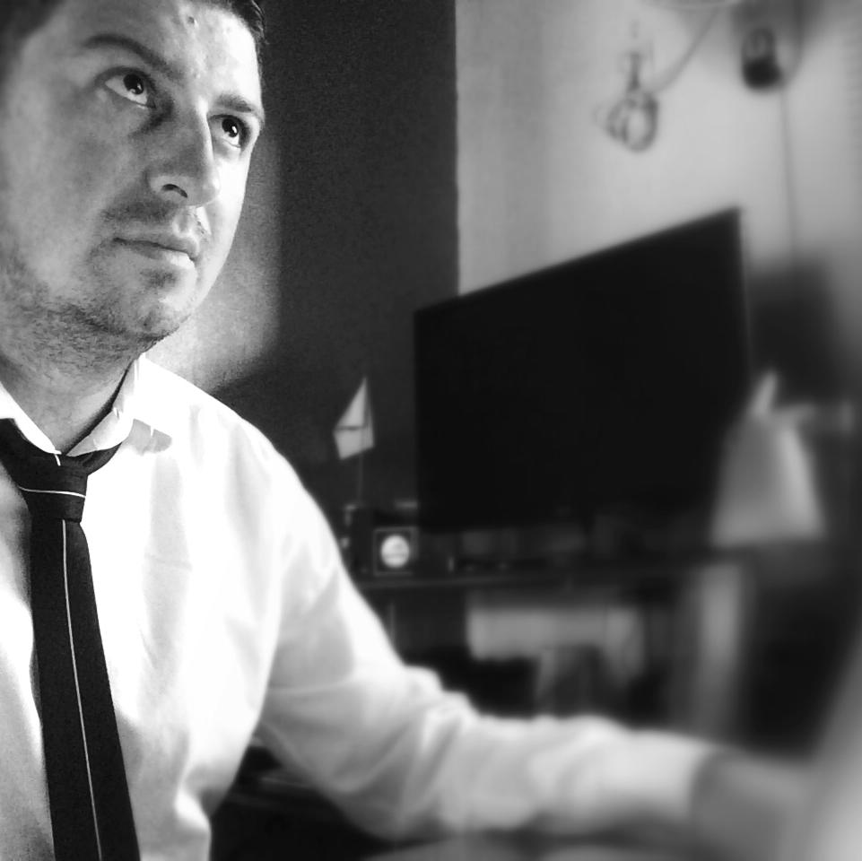
After my studies, I found myself at Saint Charles High School preparing a vocational certificate in Sales Force, the involvement of teachers, their dynamics, definitely convinced me and seduced me , it also made me realize that the sales area was what I was made for .
During those two years I had the chance to perform my internship in a company located in France in the automobile sector which is one of my passions . Thanks to the experience I gained all along this internship, back home , I was introduced to Abdul Cadjee and offered a position as a salesman in the company .That was a real enriching and rewarding experience not only for the acquaintance of such a great man as Mr Cadjee but also for the contacts and links I established.
Naturally, I joined the family business later, I was able to bring some changes, but I also realized that it was hard to want to rush things while I was still seen as the child who is behind the counter, this uncomfortable situation just complicated the states of things and was a brake to my learning and professional development. Team spirit and cohesion had no real meaning in such a situation and rapidly got tired enough to lose my energy. Family business was not made for me.
After 12 years of working in the family business a meeting came to disrupt all that, a conversation , the planning stages of a project rekindled the flame for entrepreneurial adventure. So I set up and ran my own consulting company which lasted 3 years.
Another meeting led me get closer to an international group which at the first contact convinced me, that was what I always wanted to do. I was entrusted with the development of a brand, for a year I had to fight with the central purchasing for referrals, settlements, ... .. follow-up, marketing plans, ...... field work , a sales method and I was discovering and which I liked . It was hard but it was worth it.
The group later decided to set up a branch in Reunion Island for the Indian Ocean region, I was in charge of the management and development of other structures on the island, a new challenge which makes me feel blessed today .
My goals are simple, to develop the structures , 3 of them are currently being set up , the recruiting of my staff .... These are large-scale projects which will allow me to work on an international basis . My position is one full of responsabilities, I represent the image of the company, there is no place left for mistakes and guesswork . So I will therefore have to do my utmost to be the best and to be shouldered by the best team. Business is a sports team which for me is like rugby, it has lines, methods, rules, you know you will take hits, some will be wounded, but ultimate victory is pure wonder .
"Business is a sports team which for me is like rugby, it has lines, methods, rules, you know you will take hits, some will be wounded, but ultimate victory is pure wonder."
Pierre FOLIO

That is why I am committed and try to give a helping hand to the youngest, but not with the aim of telling them that I have the solution, that they have to like things that way or another .... Just to allow them to discover the world of trade, to show them that path and to make them discover if they are made for it or not. It is a vocation, you do not become a good

seller, sales are in the soul, the techniques just let it being revealed. This will allow them to see if they eventually became a salesman by any chance or they chose it knowingly.
The de-materialized sales techniques that take precedence over traditional sales will disrupt this trade, and we must jump on the bandwagon now, young people are not aware of this shift , they missed the 10 past years evolution, they were just born with it .
For Canal Numérique (Digital Channel), we are right in this move for dynamic display, more and more cities or rod axis prohibit the 4x3 conventional display, so this mode of communication must evolve. Also taking into
account the visual and environmental pollution linked to the printings , we have a product that meets this change. "For the Street marketing , a growing number of young people can’t take their eyes off their mobile, tablets, ...... totems .... are no longer visible, to bring the communication directly on their mobile is a solution, while mastering this technology without being too intrusive for it to be the most effective. That is our development goal".

